FACULTY EVALUATION
Programme Name: Social Entrepreneurship Development Program (SEDP)- Advance Tanzania (2nd February - 6th February 2026)
Session: Operations and Efficiency
Faculty Name: Dr. Diana Kageha Ominde
No. of Respondents: 21
No. of Participants: 21
Evaluation Parameter | (%) Individual Score | (%) Programme Average
Punctuality (Commencement and Completion of Sessions) | 93 | 95
How well do you understand the core concepts presented? | 90 | 90
Rate your confidence in applying the new skills learnt | 90 | 91
Degree of Faculty preparedness for the sessions | 93 | 94
Content and methodology of the program | 93 | 94
Quality of class and group discussions | 90 | 92
The information presented in the course is relevant to my work (ministry) | 94 | 94
Average scores | 92 | 93

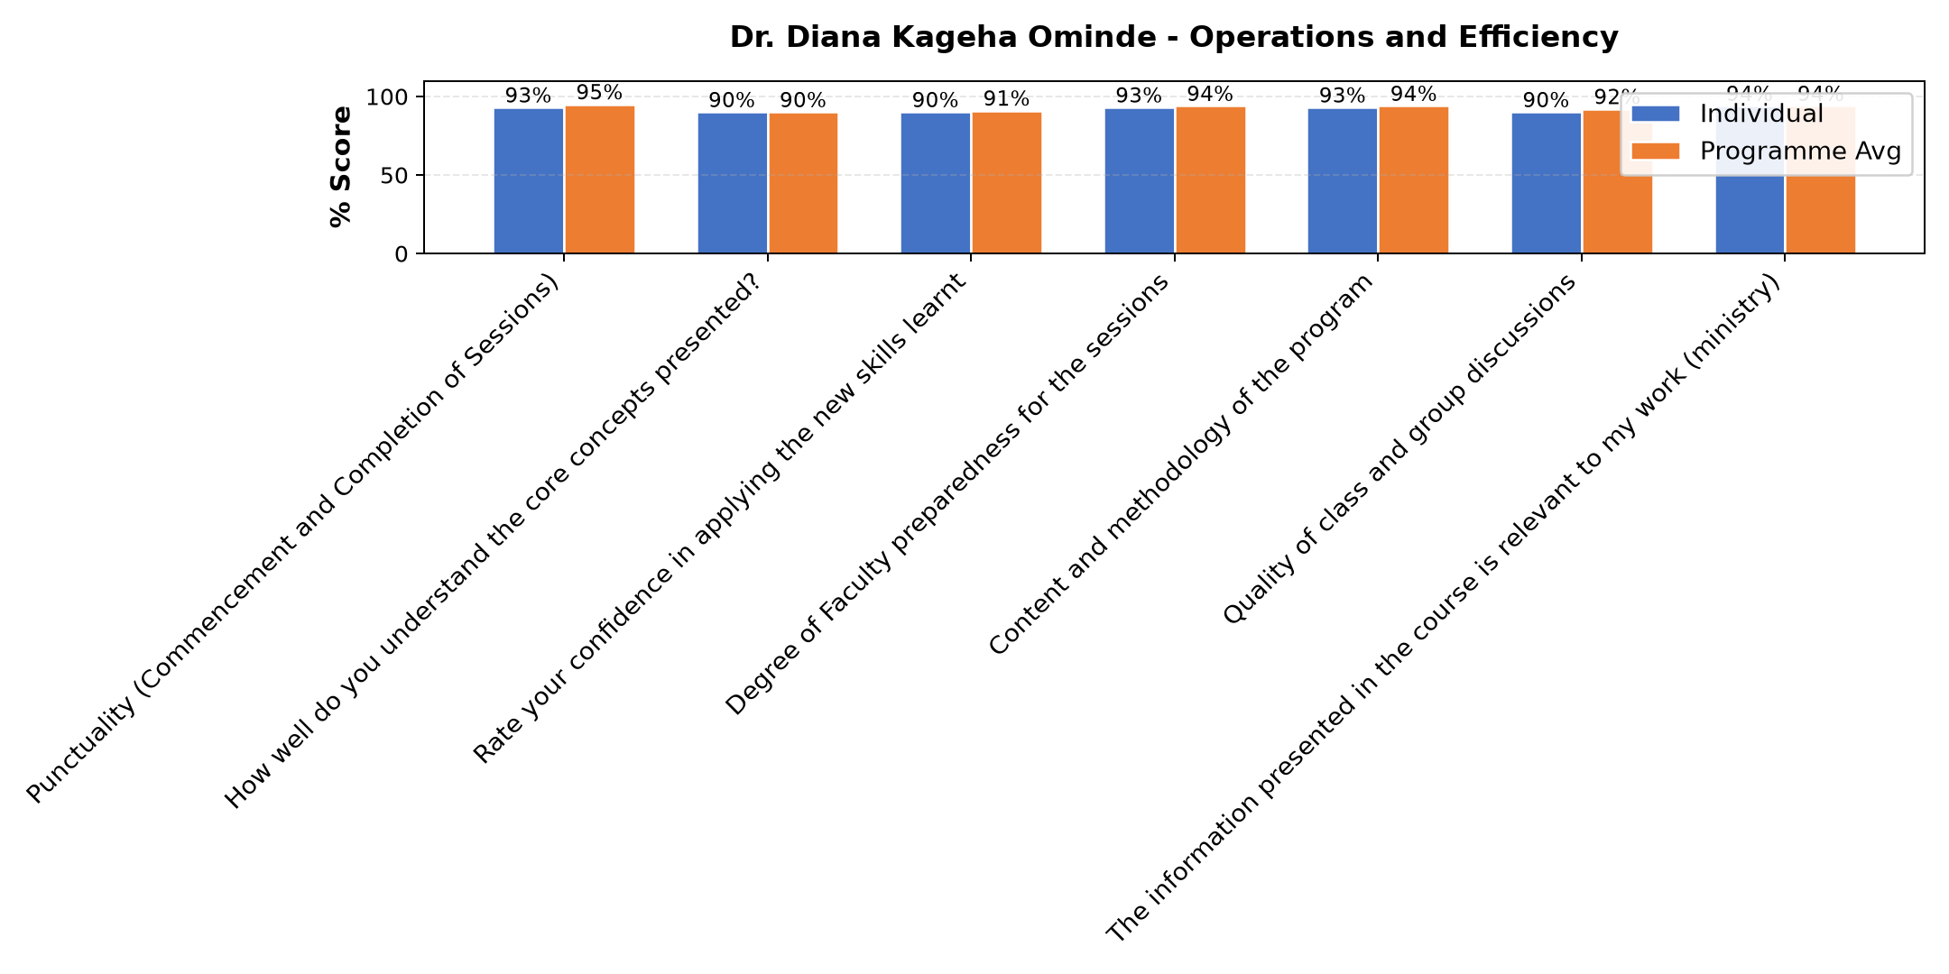

Comments & Feedback
- • Kufanya kaxi na watu tunaotofautiana malengo.
- • Mwl amefundisha vizuri
- • Team effectiveness
- • Amejitahidisana.
- • Ametumia uzoefu kadiri ya uwezo wake
- • Amewapa chemsha ubongo wanafunzi na kutoa motisha.
- • Nimejifunza ,kwamba ,hatua za kimkakati,kuimarisha mifumo ya uendeshaji,
- • Kutambua mambo yanayopunguza ufanisi
- • .kuweka majukumu wazi
- • .upimaji na utendaji
- • Non
- • Sina kipingamizi chochote, nitajitaji kufanyia kazi ujuzi wote ulionipa asante
- • Mostly to work with lay people in our institution without our fellow sisters
- • Understood by me.
- • No barrier can prevent me to implement
- • Lack of personal and enough money
SUBMITTED THROUGH:
SBS Evaluation Automation System

